**ECEN 5032**

**WIRELESS LANs**

**HOMEWORK 2**

**SUBMITTED BY:**

**SOWMYA RAMAKRISHNAN**

**108684769**

The variation of bit error rate with transmission signal clipping was observed in this exercise using MATLAB. The code to construct an OFDM signal, pass it through a channel that adds additive white Gaussian noise (AWGN), demodulate it and measure bit errors compared to the theoretical value was opened in MATLAB by entering the command line as given in the exercise.

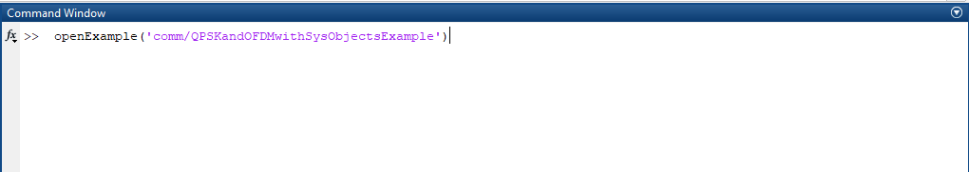

To make the example more closely match 802.11a, the values of symbol and cyclic prefix length were changed. The original values:

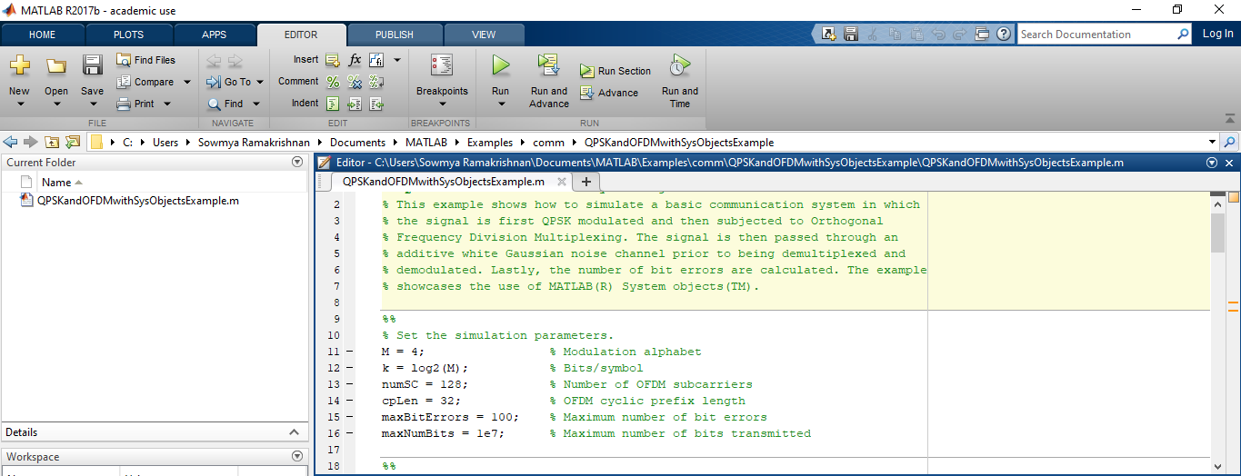

The values were changed to numSC=64 and cpLen=16.

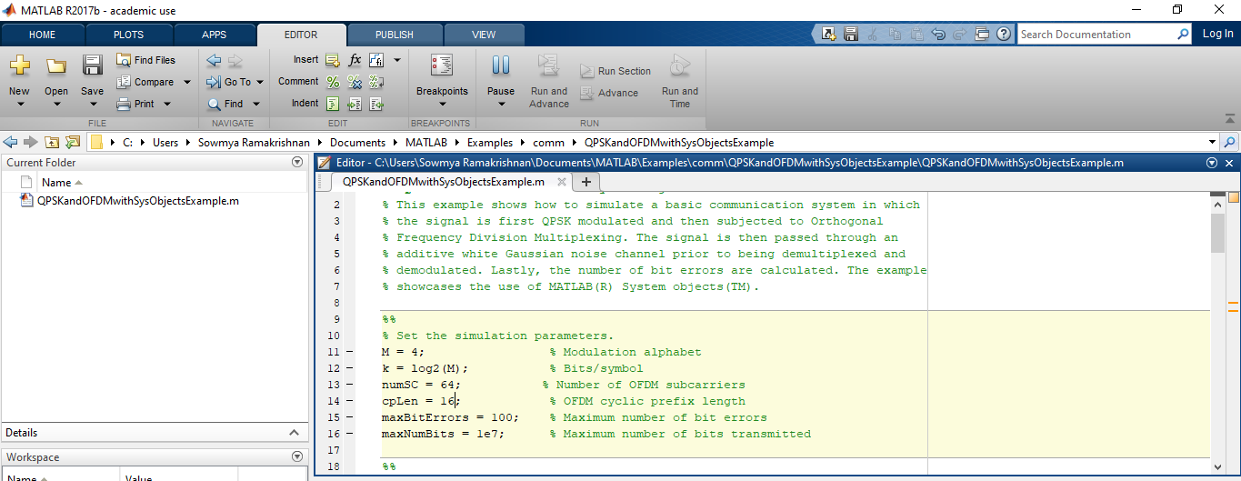

The code was then run to obtain a simulation(graph), with no clipping as follows.

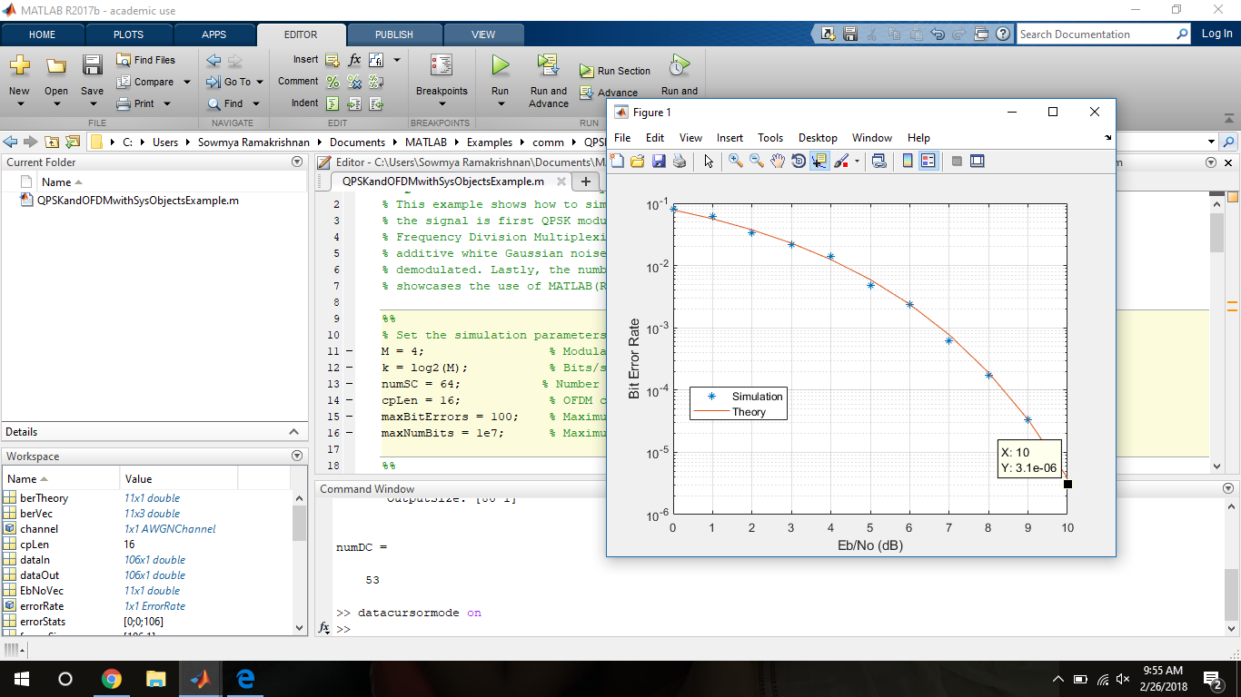

Clipping was introduced on the transmit signal before going into the AWGN channel. The given lines of code were inserted in the while loop after the noiseVar statement.

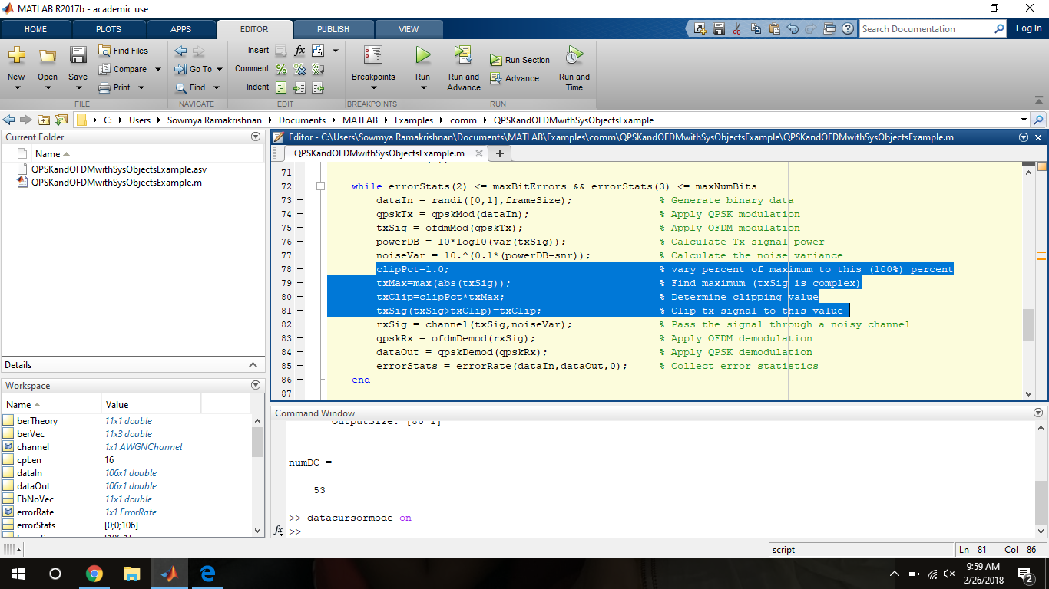

The clipping level was then varied (from 100% or clipPct=1.0-No clipping) to lower percentages of the maximum (20% or 0.2), and the BER variation was calculated/observed at 1odB Eb/N0 at each clipping level.

To obtain as accurate a value as possible, the plot obtained was magnified multiple times and then the marker was used on the point to get the accurate value of the simulation BER.

An example of magnification that was used, is shown.

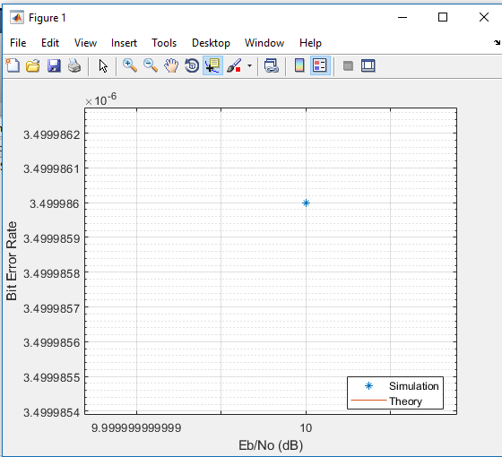

The screenshots of variation of clipping level and corresponding simulated BER values are as follows.

**Clipping Level=1.0**

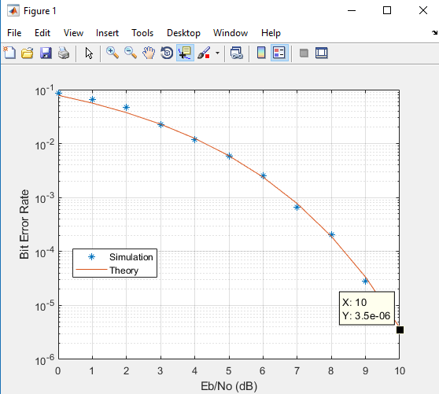

**Clipping Level=0.9**

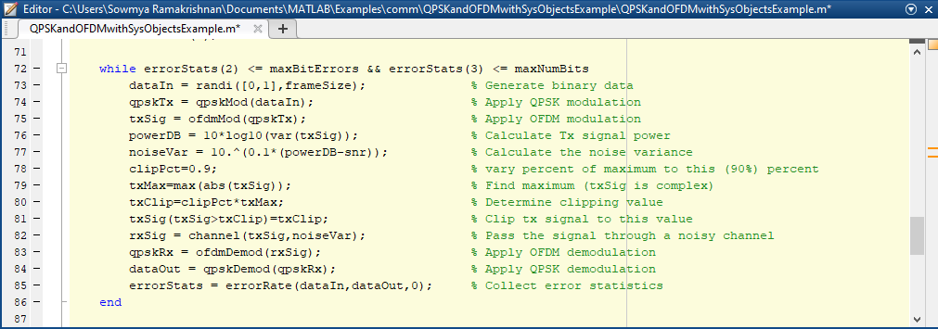

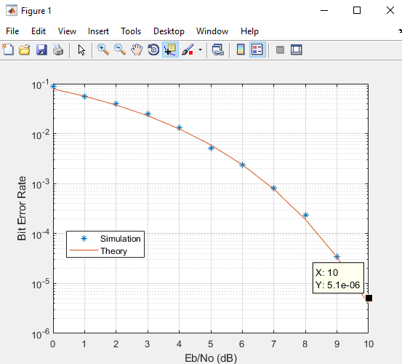

**Clipping Level=0.8**

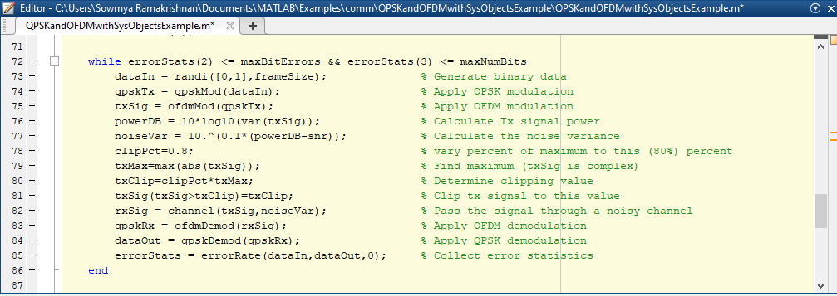

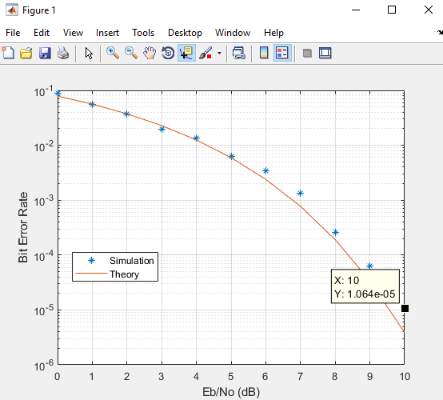

**Clipping Level=0.7**

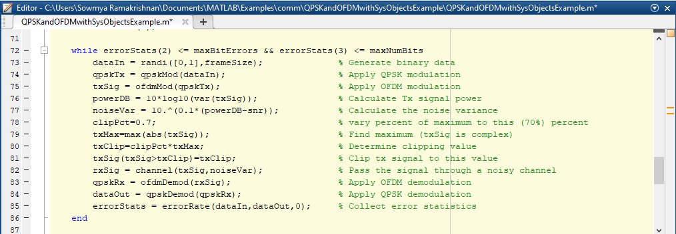

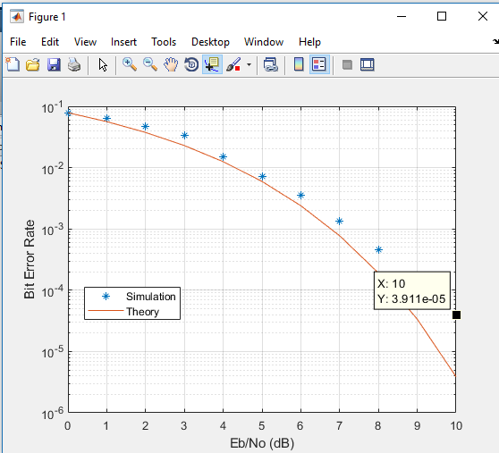

**Clipping Level=0.6**

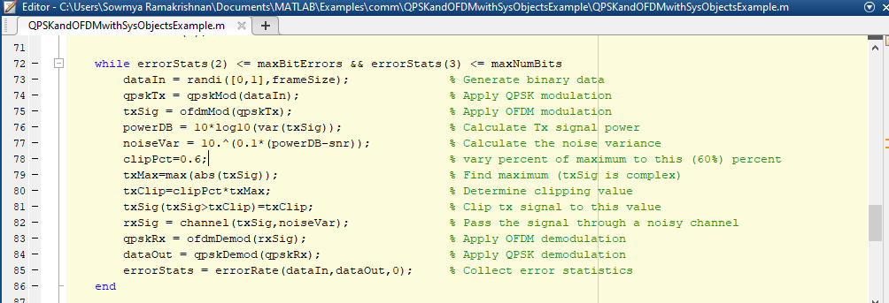

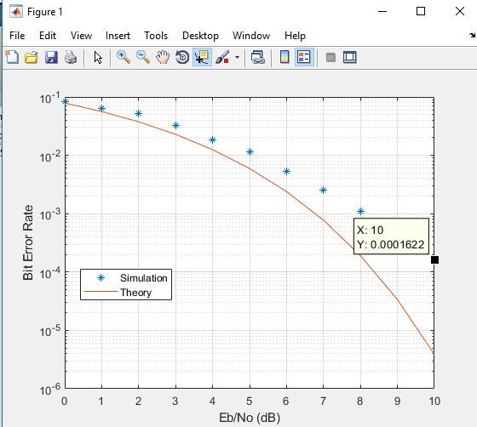

**Clipping Level=0.5**

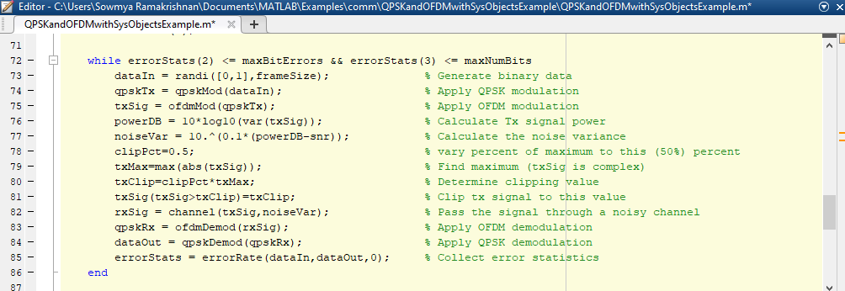

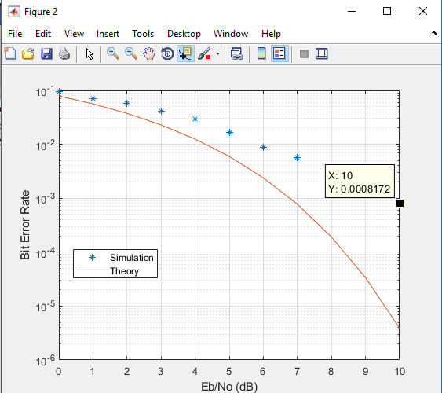

**Clipping Level=0.4**

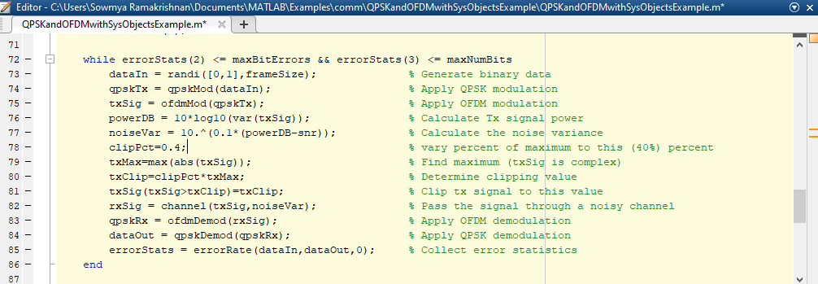

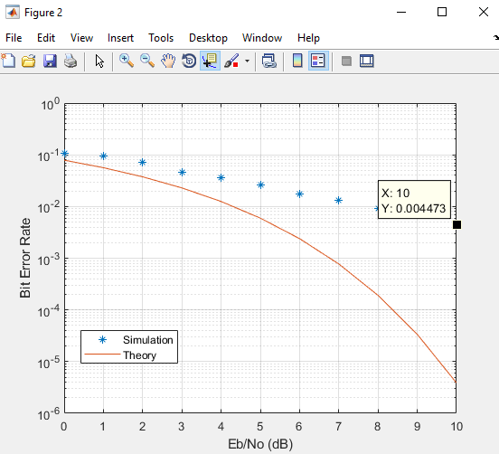

**Clipping Level=0.3**

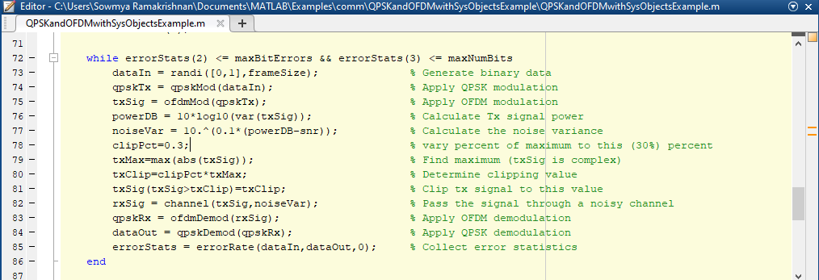

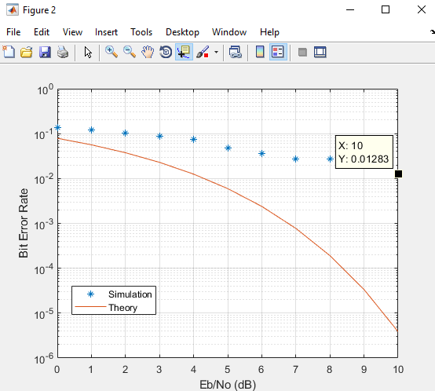

**Clipping Level=0.2**

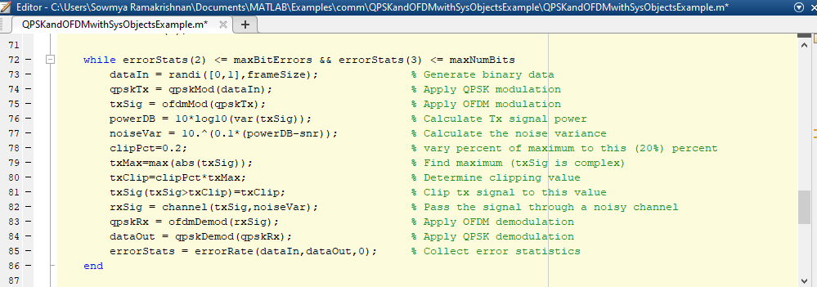

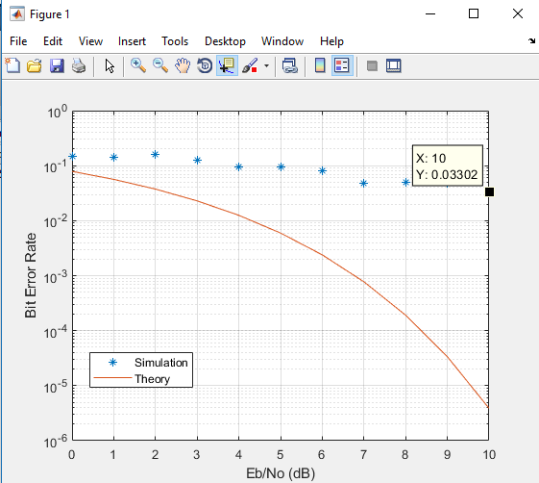

**The simulated BER values corresponding to the clipping level were saved in an Excel sheet, as follows.**

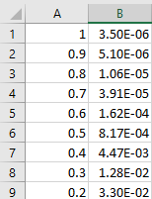

The BER vs Clip percent graph was plotted as a line graph in Excel and as a scatter plot in MATLAB.

**Line graph:**

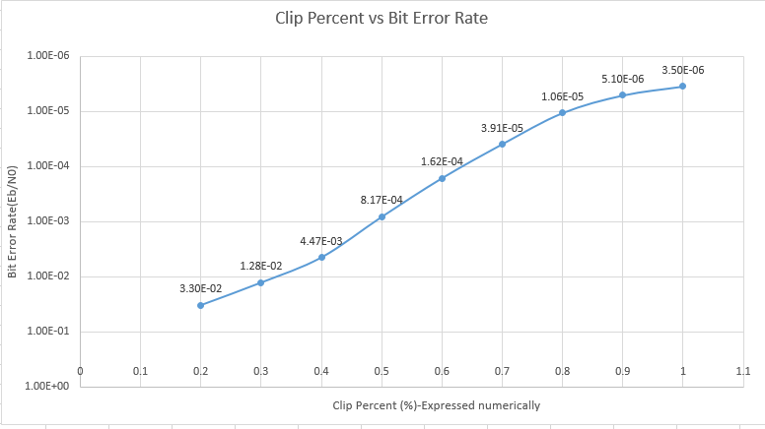

**Scatter Plot:**

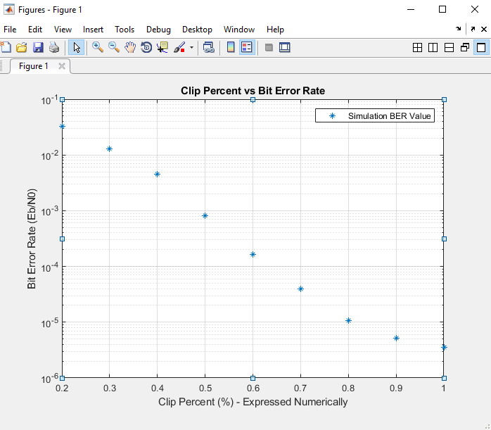

In both these graphs, the Clip percent is expressed numerically (from 1.0 to 0.2-corresponding to 100% to 20%).

It is noticed that the BER is lowest when there is clipping level 1.0 or 100% and highest when clipping level is 0.2(20%).

The BER thus increases with clipping. More the clipping, more the BER.

In the first graph, The BER values are in descending order while in the scatter plot, the BER values are in ascending order.

Thus, the variation in BER values with clipping level was thus studied through this exercise.